Alberta Library Trustees’ Association Annual General Meeting Minutes
Saturday, June 13th, 2020, 9:30 a.m.
ZOOM Video Conference
____________________________________________________________________________________

- Tanya Pollard called the 2020 ALTA Annual General Meeting to Order at 9:35 a.m. Opening remarks, welcome Trustees & Honorary Lifetime Members, Students & Guests

- Approval of Agenda

Motion by Vicky Lefebvre, seconded by Mark Walters to approve the agenda. Carried.

- Approval of 2019 Annual General Meeting minutes
Motion by Denise van Rootselaar, seconded by Douglas Davey, to approve 2019 AGM Minutes. Carried.

- No Business arising from the Minutes

- Annual Reports
President Report, Dr. Tanya Pollard
Executive Director’s Report, Heather Mayor-Coulson

Motion by Grant Clark and seconded by Sharolyn Sanchez to accept the Annual Reports. Carried.

- Financial Report
2019 Notice to Reader, financial report by Kouri* Berezan *Heinrichs, Chartered Accountants.
Presented by Heather Mayor

Motion by Mark Walters to approve the 2019 Notice to Reader, seconded by Vicki Leder
Carried.

Appoint 2020 Financial Review
Motion by Craig Lukinuk to approve the appointment of 2020 Notice to Reader to Kouri* Berezan *Heinrichs, Chartered Accountants, seconded by Vicki Lefebvre. Carried.

- Membership Resolution: Background
For over 49 years, ALTA has provided support and resources for trustees. It is imperative that ALTA adapts to this changing library landscape or risk closing the doors.
In the past, ALTA has had flexibility surrounding how funding was spent. Due to budgetary changes, ALTA can no longer depend on those funds to support its operations. In spite of all of the changes, ALTA’s fees have remained low, one membership fee covers the entire library board and fees have not increased in 9 years. In order to continue to support our fundamental operations and roll out new initiatives, such as webinar series, further development on the online forum and additional training materials to support trustee growth, ALTA must amend its fee schedule to continue to remain viable.
Membership Resolution:
ALTA UPDATES ITS FEE SCHEDULE TO THE PROPOSED FEE SCHEDULE TO CONTINUE OPERATIONS
WHEREAS ALTA has not increased its membership fees since 2012 and
WHEREAS ALTA can not depend on or have direct oversight on grant funding and
WHERE AS funding must be sourced to sustain basic operations and operations for new projects
Be it resolved that ALTA adjust its fee schedule to reflect the proposed model.

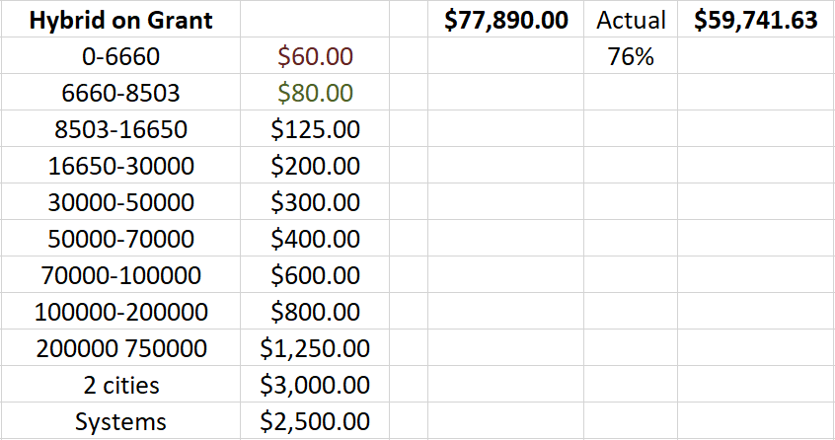

Motion by Helen Veno to approve the membership resolution, seconded by Denise van Rootselaar. Carried.

- New 2020-23 ALTA Board nominations

Election of Officers,

Voted in by Acclamation for 2020-22 ALTA Board of Directors: (in Bold)

Area 1 (Peace), Camille Zavisha 2019 - 2021

Area 2 (Yellowhead), Hank Smit 2020 - 2022

Area 3 (Parkland), Bob Green 2019 – 2021

Area 4 (Marigold), Lennox Gomes 2020 – 2022

Area 5 (Chinook Arch), Vic Mensch 2019 - 2021

Area 6 (Shortgrass) OPEN 2020 - 2022

Area 7 Metro Edmonton, Craig Blackmore 2019 - 2021

Area 8 Northern Lights, Jennifer Anheliger 2020 - 2022

EPL Pending 2019 - 2021

CPL Joycelyn Phu 2019 - 2021

Alternates Area 1 (Peace) Denise Joudrey 2019 - 2021

Area 4 (Marigold), Geoff Ball 2020 - 2022
.

Motion by Douglas Davey to accept the acclamations, seconded by Amanda Yawarski. Carried.

9. Adjourn
Motion by Bob Green to adjourn the AGM. Carried.

